Abstract Title(18pt Calibri Using Capitalization Only on First Letter of Major Words and Centered, 1line spacing)

Author’s Name1^{1*}, Author’s Name2², Author’s Name3¹ (11 pt Calibri and Centered)
¹Affiliation A, Korea
²Affiliation B, Korea (10pt Italic, Calibri and Centered, 1line spacing)

Abstracts must be written clearly in English or Korean and submitted prior to Jun 7(Mon.), 2021. Authors may further edit and modify submitted abstracts until the submission deadline. Title—Use a concise title that reflects the content of the abstract. The complete title should be capitalized the first letter. Authors—Full names including surnames for each author must be provided. Do not include degrees or titles. Presenting author’s name should be placed at the very front and marked withasterisk (*) following the name. Corresponding author’s name is the same with presenting author’s name. Affiliations—Affiliation should include institution and department. Contents—Abstract should be typed in Calibri 10 point font, vertical, A4 sized paper (21.0 by 29.7 cm). Also it should be one page or within less two pages. Submitted abstract will be reproduced exactly as submitted. Images—If an abstract includes images, they should be placed at the middle of the abstract or at the end of the abstract. Specify the image resolution in 300 dpi.

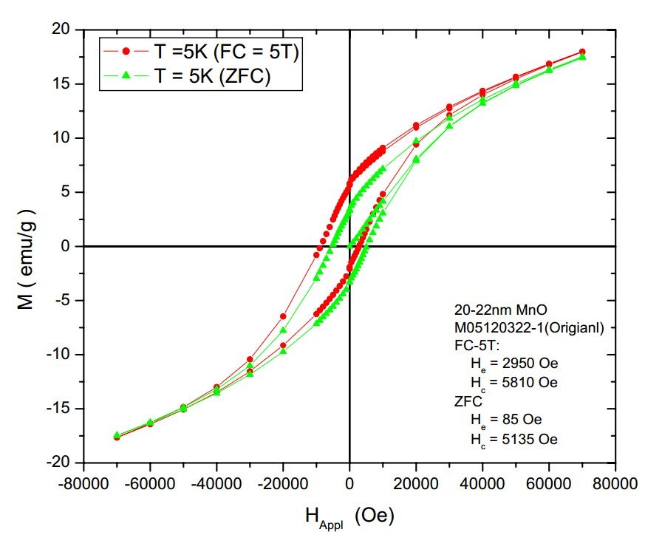
Fig. 1. A sample line graph
(1line spacing / image size: 300 dpi)

